**Preparing and Testing Network Jumpers**

Student Version



Huawei Technologies Co., Ltd.

|  |
| --- |
| **Copyright © Huawei Technologies Co., Ltd. 2020. All rights reserved.**  No part of this document may be reproduced or transmitted in any form or by any means without prior written consent of Huawei Technologies Co., Ltd.  **Trademarks and Permissions**  HW_POS_RBG_Vertical-150ppi.png and other Huawei trademarks are trademarks of Huawei Technologies Co., Ltd.  All other trademarks and trade names mentioned in this document are the property of their respective holders.  **Notice**  The purchased products, services and features are stipulated by the contract made between Huawei and the customer. All or part of the products, services and features described in this document may not be within the purchase scope or the usage scope. Unless otherwise specified in the contract, all statements, information, and recommendations in this document are provided "AS IS" without warranties, guarantees or representations of any kind, either express or implied.  The information in this document is subject to change without notice. Every effort has been made in the preparation of this document to ensure accuracy of the contents, but all statements, information, and recommendations in this document do not constitute a warranty of any kind, express or implied. |

|  |  |
| --- | --- |
| Huawei Technologies Co., Ltd. | |
| Address: | Huawei Industrial Base  Bantian, Longgang  Shenzhen 518129  People's Republic of China |
| Website: | <https://e.huawei.com/> |

**Huawei Certification System**

Huawei Certification follows the "platform + ecosystem" development strategy, which is a new collaborative architecture of ICT infrastructure based on "Cloud-Pipe-Terminal". Huawei has set up a complete certification system consisting of three categories: ICT infrastructure certification, platform and service certification, and ICT vertical certification. It is the only certification system that covers all ICT technical fields in the industry. Huawei offers three levels of certification: Huawei Certified ICT Associate (HCIA), Huawei Certified ICT Professional (HCIP), and Huawei Certified ICT Expert (HCIE). Huawei Certification covers all ICT fields and adapts to the industry trend of ICT convergence. With its leading talent development system and certification standards, it is committed to fostering new ICT talent in the digital era, and building a sound ICT talent ecosystem.

Huawei Certified ICT Associate-Datacom (HCIA-Datacom) is designed for Huawei's frontline engineers and anyone who want to understand Huawei's datacom products and technologies. The HCIA-Datacom certification covers routing and switching principles, basic WLAN principles, network security basics, network management and O&M basics, SDN and programmability and automation basics.

The Huawei certification system introduces the industry, fosters innovation, and imparts cutting-edge datacom knowledge.

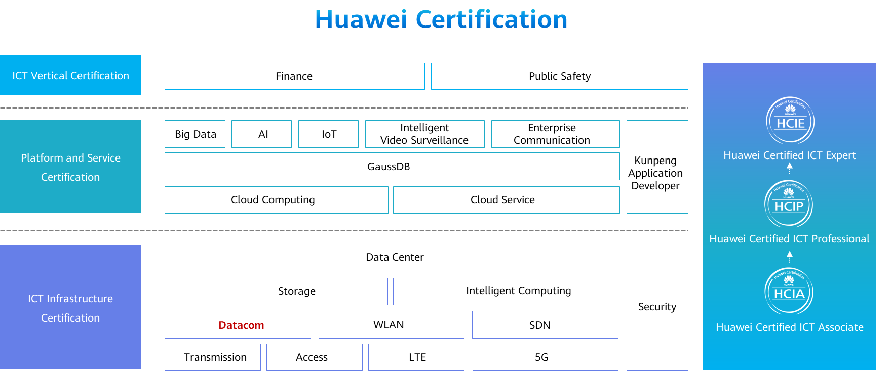

# Preparing and Testing Network Jumpers

## Background

You have just joined a company as an intern and are now participating in a network system engineering project. By now, the project was in its early phase — installation and commissioning. To improve your hands-on capabilities, the project manager arranges for you to prepare network jumpers to connect network switches, routers, and terminals to the integrated cabling system. You need to prepare two cables: one Category 5e unshielded network jumper and one Category 6 unshielded network jumper. In addition, the two cables are wired in compliance with the T568B standards on both ends and are 1.5 m long.

## Objectives

Upon completion of this exercise, you will be able to:

* Know how to make network jumpers.
* Know how to test the connectivity of network jumpers.
* Know how to use related tools.
* Be familiar with the mechanical structure and electrical principles of Ethernet cables.
* Be familiar with the mechanical structure and electrical principles of RJ45 connectors.

## System Cabling

System cabling diagram

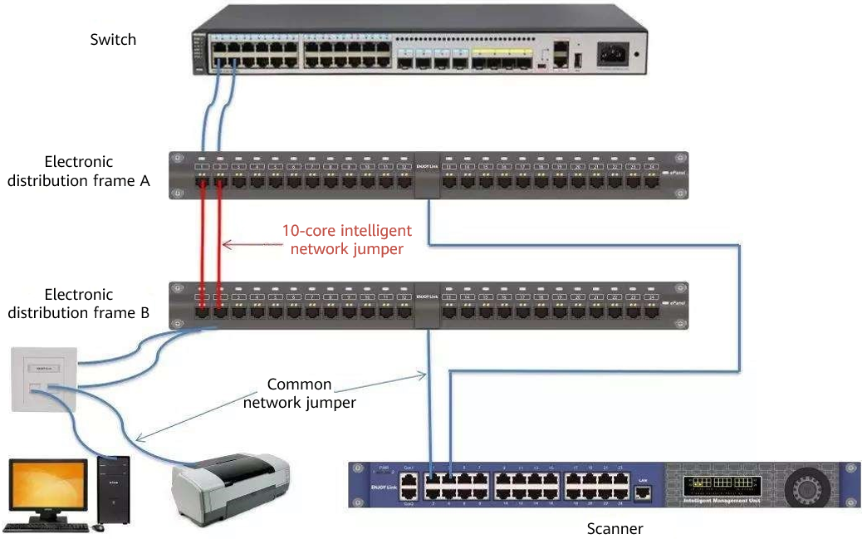

## Planning

This exercise aims to prepare one Category 5e unshielded network jumper and one Category 6 unshielded network jumper and test their connectivity. As required, the two cables are wired in compliance with T568B standards on both ends and are 1.5 m long.

### Tasks

Trim an Ethernet cable.

Strip the cable jacket.

Spread the four pairs of twisted wires apart.

Untwist the wire pairs.

Align the colored wires in the T568B orientation.

Cut the wires as straight as possible.

Insert the wires into the RJ45 connector.

Crimp the RJ45 connector.

Repeat steps 2 to 8 for the other end of the cable.

Use a cable tester to test the cable connectivity.

Perform onsite "5S".

## Implementation

### Preparations

Instrument: 1 x cable tester

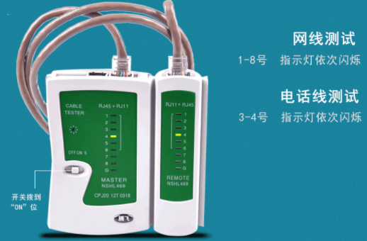

* Tools: 1 x crimping tool, 1 x wire stripper, 1 x pair of scissors, 1 x steel measuring tape

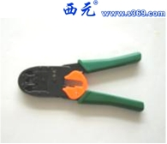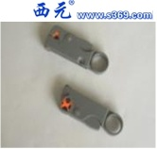

* Materials: 2 x Category 5e unshielded RJ45 connector, 1 x Category 5e unshielded Ethernet cable, 2 x Category 6 unshielded RJ45 connector, 1 x Category 6 unshielded Ethernet cable

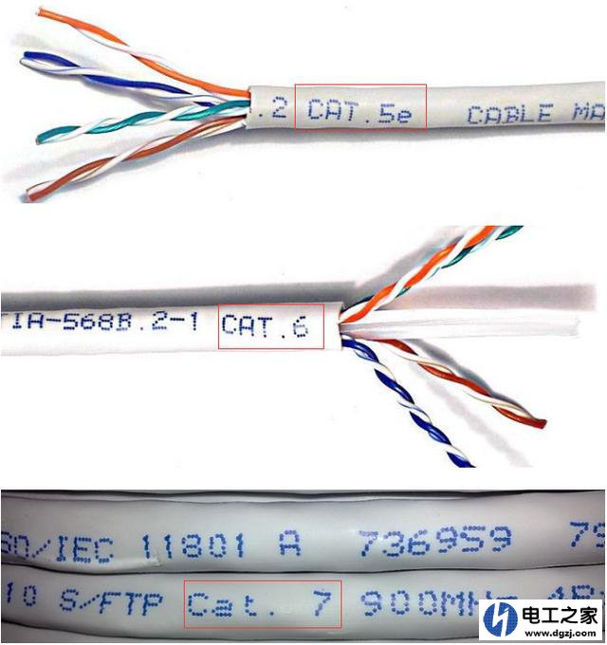

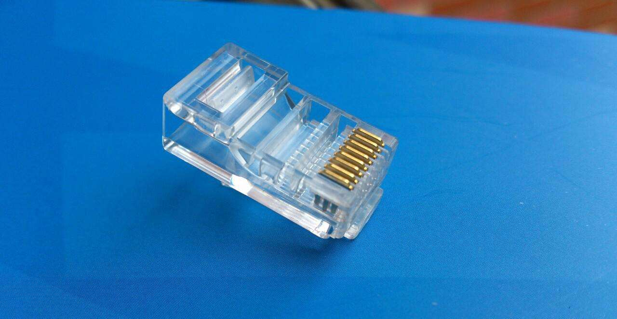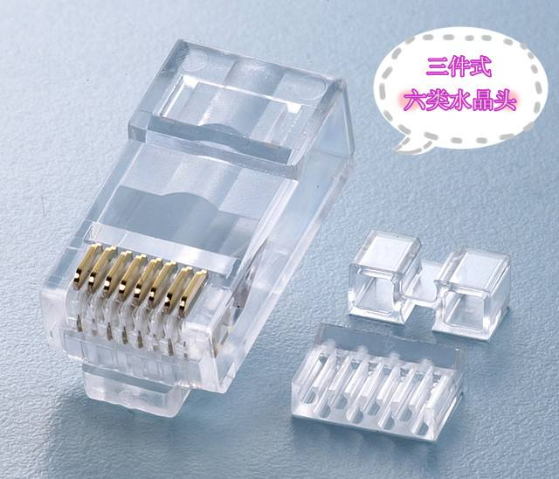

### Procedure

Trim Ethernet cables.

* Survey the project site.
* Select two Category 5e unshielded RJ45 connectors and two Category 6 unshielded RJ45 connectors.
* Considering practice loss, reserve 10 mm longer at both ends of the 1.5 m Category 5e unshielded Ethernet cable and Category 6 unshielded Ethernet cable. As such, trim two cables with a length of 1.7 m.
* Although the internal structures of the two cables are different, they are made in the same way.

Take the crimping tool or wire stripper to strip the cable jacket off.

* The crimping tool or wire stripper has a slot with a razor blade and enough clearance to cut through the cable jacket but not the wires inside. Place an Ethernet cable into the slot, gently squeeze the tool, and rotate the cable to strip 20–40 mm off the outer jacket from the end. Make sure the outer jacket to be stripped off is within this range; otherwise, subsequent operations will be adversely affected. Practices will help you properly measure the outer jacket.
* Place an Ethernet cable into the slot, gently squeeze the tool, and rotate the cable 360 or 720 degrees clockwise to strip 20–40 mm off the outer jacket from the end. Do not bend the cable too much to avoid damaging the twisted pair structure. Do not damage the insulation layers of the eight wires, not to mention any bare copper conductor. Check the wires carefully after removing the cable jacket.
* Use scissors to cut off the pull string. For the Category 6 cable, cut off the cross framework in the middle.

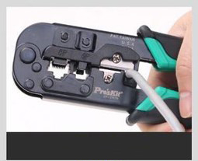 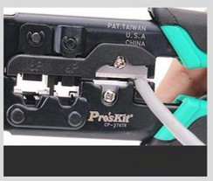 

Spread the four pairs of twisted wires apart.

Place the four pairs of twisted wires in the sequence of orange, blue, green, and brown from left to right.

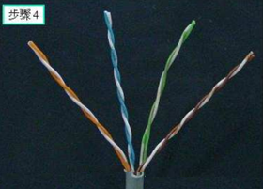

Untwist all four pairs of wires.

* Untwist the pair of orange and orange/white wires first and arrange them from left to right in a color sequence of orange/white and orange. Untwist wires against their twisting directions and straighten them.
* Follow this method to untwist the other three pairs. For each of the other three pairs, arrange two wires from left to right in a sequence of solid color/white and solid color. (These pairs come in different colors, with one being a solid color and the other being a white wire with a stripe matching the solid color.)
* Now, the eight wires from left to right are in the following color sequence: orange/white, orange, blue/white, blue, green/white, green, brown/white, and brown.

Put the eight wires in order according to the T568B wiring standards.

Switch the blue/white wire with the green/white wire. Check the wiring sequence against T568B. As defined in T568B, the wiring sequence shall be: orange/white, orange, green/white, blue, blue/white, green, brown/white, and brown.

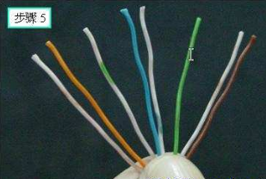

Trim the ends of wires.

Make a straight cut across the eight wires to leave about 12 mm above the end of the cable jacket.

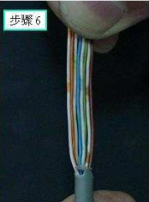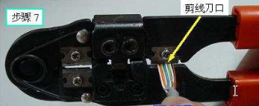

Insert the wires into an RJ45 connector.

* Pinch the wires with your left hand to keep the color order unchanged. Hold the RJ45 connector with your right hand, keeping the clip facing down or away from you.
* Slide the wires into the connector, making sure that the cable jacket exceeds the stop of the connector and each wire goes into its own slot. Evenly push the cable all the way in until all eight wires touch the end of the connector. As you do this, make sure that none of the wires jumps out of order.

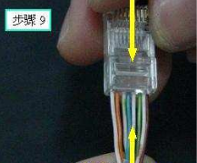 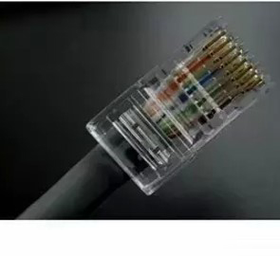

Crimp the RJ45 connector.

* Carefully place the RJ45 connector into the crimping slot of the crimping tool.
* Once the connector is all the way in, squeeze down on the tool to crimp the connector. When you hear a click, the connector is ready to use.

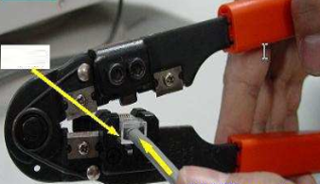 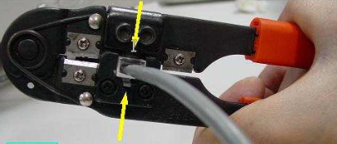

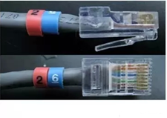 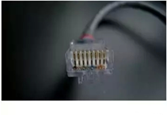

Repeat steps 2 to 8 for the other end of the cable.

Check the wiring sequence.

|  |  |  |  |  |  |  |  |  |
| --- | --- | --- | --- | --- | --- | --- | --- | --- |
| Pin Assignment | 1 | 2 | 3 | 4 | 5 | 6 | 7 | 8 |
| Connector A | Orange/white | Orange | Green/white | Blue | Blue/white | Green | Brown/white | Brown |
| Connector B | Orange/white | Orange | Green/white | Blue | Blue/white | Green | Brown/white | Brown |

Test the cable connectivity.

* Insert the RJ45 connectors on both ends of the cable into the ports on the main tester unit and remote tester unit, respectively. Turn the switch to ON.
* If indicators on both the main tester unit and remote tester unit blink in the same sequence at the same time, this cable can work properly.

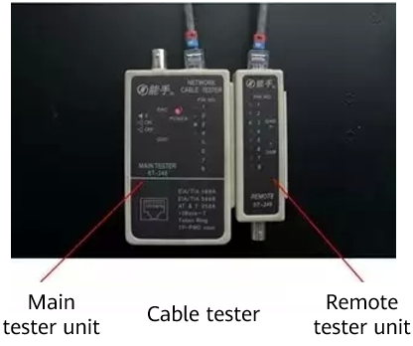

Perform onsite "5S".

----End

## Project Result Records

### Connectivity Verification Test Data Record

| Network Jumper Type | 1-1 | 2-2 | 3-3 | 4-4 | 5-5 | 6-6 | 7-7 | 8-8 |
| --- | --- | --- | --- | --- | --- | --- | --- | --- |
| Category 5e Unshielded |  |  |  |  |  |  |  |  |
| Category 6 Unshielded |  |  |  |  |  |  |  |  |

### Process Self-Assessment

|  |  |  |  |  |
| --- | --- | --- | --- | --- |
| Self-Assessment Dimensions  (Whether Requirements Are Met) | 1.7 m Long (Length Deviation ≤ 5 mm) | Pull Strings Are Cut Off on Both Ends | Cable Jackets Are Tightly Crimped Inside RJ45 Connectors | Passed the Connectivity Test |
| Category 5e unshielded |  |  |  |  |
| Category 6 unshielded |  |  |  |  |

### Operation Self-Assessment

|  |  |  |  |  |  |
| --- | --- | --- | --- | --- | --- |
| Score | Procedure | Instrument Usage | Tool Usage | Operation Standardization | Onsite "5S" |
| Category 5e unshielded |  |  |  |  |  |
| Category 6 unshielded |  |  |  |  |  |